**PDP Lab. 6**

**-documentation-**

**Algorithms:**

* The directed graph is represented as follows: the nodes are labeled with integers in range [0, n), where n is the number of nodes; the vertices are kept as a set of target nodes for each (starting) node.
* In order to find a Hamiltonian cycle, partial solutions are built using backtracking and the first valid candidate solution will be returned; if no such solution is found, i.e. there are no Hamiltonian cycles in the graph, null will be returned.
* A number of maximum threads will be given as input. As long as this number is not reached, the algorithm will use 2-paralel explore with recursive decomposition by launching a new thread on callback; otherwise, the callback is called sequentially.

**Synchronization:**

* In order to protect the result variable, a lock is used in this fashion: when a valid candidate solution was found, it acquires the lock, checks if in the meantime the result has been already set and, if not, set it to the current solution, then release the lock.
* Also, if the result is already set at the beginning of the execution of a callback, it will return immediately.

**Performance:**

*Notice that the maximum number of callbacks is the maximum number of threads the algorithm can use (not greater than n!, where n is the number of nodes in the graph).

For graph:

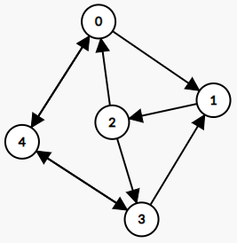

|  |  |
| --- | --- |
| NO. OF THREADS | TIME (ms) |
| 0 | 201 |
| 1 | 917 |
| 2 | 789 |
| 3 | 984 |
| 4 | 1249 |
| 5 | 1906 |
| 6 | 2299 |
| 7 | 1542 |
| 8 | 1218 |
| 9 | 1236 |
| 10 | 1370 |
| 11 | 1355 |
| 12 | 2005 |
| 13 | 4434 |
| 14 | 2083 |
| 15 | 2345 |
| 16 | 2258 |
| 17 | 3042 |
| 18 | 2419 |
| 19 | 2325 |
| 20 | 3128 |
| 21 | 3471 |
| 22 | 6753 |
| 23 | 2515 |
| 24 | 2727 |
| 25 | 2592 |
| 26 | 5786 |
| 27 | 3586 |
| 28 | 3019 |
| 29 | 5598 |